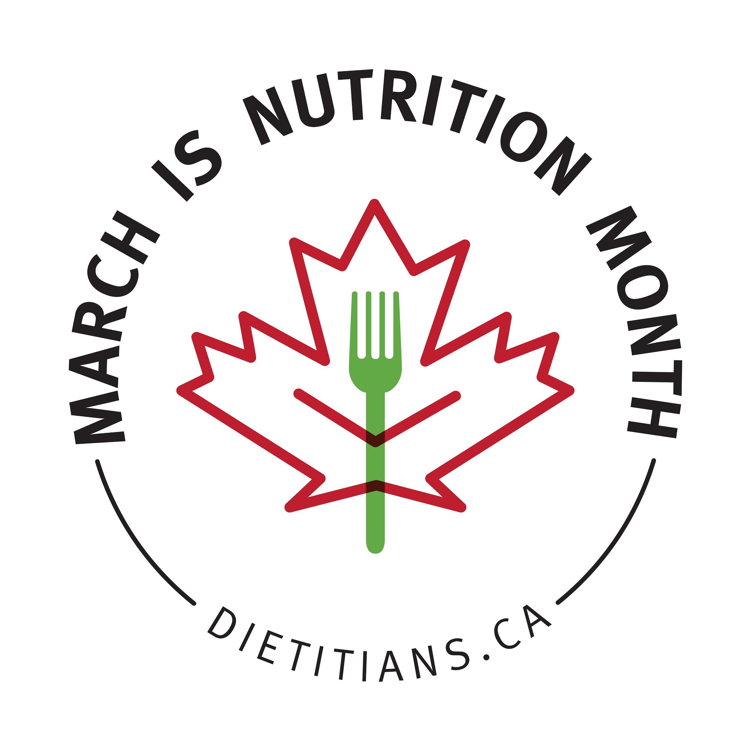
Nutrition Month 2021
Social Media Toolkit

nutritionmonth2021.ca

About the theme:
The Nutrition Month 2021 theme, “Good for you! Dietitians help you find your healthy” centres on the idea that healthy eating looks different for everyone. As dietitians, we recognize that each client has their own culture and traditions, preferences and nutritional needs. We are uniquely positioned to consider all of these factors when providing advice and guidance.

Nutrition Month 2021 is an opportunity to share timely examples of how your work takes these factors into consideration, whether you work with clients, communities or the population at large! Read the stories of 10 dietitians and learn more about the theme in the Nutrition Month 2021 Activity and Ideas Guide.

About this toolkit:
Use the 25 posts in this toolkit on social media or for your newsletters and websites. Don’t forget to include #NutritionMonth and #FindYourHealthy in your tweets and direct your
followers to nutritionmonth2021.ca
Find corresponding graphics sized for use on websites, email signatures, social media banners and social media posts on the Nutrition Month resource page.
Writing an article for your workplace newsletter, website, blog or creating content for social media is a great way to promote healthy eating habits and to help others become familiar with the role and value of a dietitian. Find story ideas in the Nutrition Month 2021 Activity and Ideas Guide.
Questions? Email nutritionmonth@dietitians.ca.
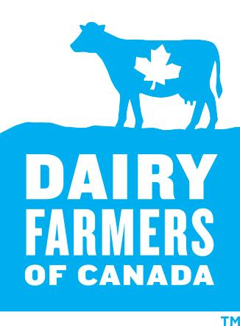
Dietitians of Canada acknowledges the support of Nutrition Month Official Sponsor Dairy Farmers of Canada who help bring Nutrition Month 2021 to Canadians.
The content, planning and execution of Nutrition Month is protected by Dietitians of Canada’s Guidelines and Principles for Private Sector Relationships. The Nutrition Month Sponsor Prospectus is available on the Dietitians of Canada website

General Posts
March is Nutrition Month! This year, dietitians want you to know that there is no ‘one-size-fits-all’ approach to healthy eating - let us help YOU find YOUR healthy! Find recipes, articles and more at NutritionMonth2021.ca #NutritionMonth #FindYourHealthy
Healthy eating looks different for everyone. This #NutritionMonth, dietitians across Canada will help you #FindYourHealthy, guiding your nutrition goals in a way that is Good For You! Learn more at NutritionMonth2021.ca
This March, find a dietitian at NutritionMonth2021.ca and find your healthy! Dietitians are trained and trusted health care professionals who help cut through the clutter with personalized nutrition advice. #NutritionMonth #FindYourHealthy
Happy #DietitiansDay (March 17)! Today we celebrate dietitians as regulated health care professionals, committed to using their specialized knowledge and skills to support healthy living for all Canadians. Learn more: NutritionMonth2021.ca #NutritionMonth #FindYourHealthy

Recipes:
There are 15 new recipes available in a free e-book for Nutrition Month. Here are sample social media posts featuring some of the recipes:
Hungry? There are 15 delicious new recipes for Nutrition Month at https://bit.ly/2M8cjfo #NutritionMonth #FindYourHealthy
Have you downloaded the Nutrition Month 2021 Recipe eBook? It includes 15 delicious recipes, hand-picked by dietitians. Which recipe will you try first? Find it at https://bit.ly/2M8cjfo #NutritionMonth #FindYourHealthy
Dietitian Tip: It’s important to expose children to many different food cultures at an early age. Always approach new foods with an open mind! Try this recipe: Spicy Red Lentil and Havarti Soup - available at https://bit.ly/2M8cjfo #NutritionMonth #FindYourHealthy
Dietitians want you to enjoy your food! Eat in a way that works with your culture and traditions, preferences and nutritional needs. Try this recipe: Garlic Tomato Chickpeas - available at https://bit.ly/2M8cjfo #NutritionMonth #FindYourHealthy
Eating with others is a great way to connect and explore cultural and traditional foods. Try this recipe: Pan-Fried Dates with Cardamom Yogurt - available at https://bit.ly/2M8cjfo #NutritionMonth #FindYourHealthy
Do you struggle to make time for breakfast? Try preparing it in the evening. This can help save time the next morning and start your day off great! Try this recipe: Pear Raspberry Yogurt Muesli - available at https://bit.ly/2M8cjfo #NutritionMonth #FindYourHealthy
Healthy eating looks different for everyone. Add variety to your diet and find what works for you! Try this recipe: Lemony Ginger Milk-And-Honey Tea - available at https://bit.ly/2M8cjfo #NutritionMonth #FindYourHealthy
Dietitian Tip: Cooking with your loved ones is an excellent way to bond while learning an important skill. Try this recipe: Citrusy Chicken Salad with Feta - available at https://bit.ly/2M8cjfo #NutritionMonth #FindYourHealthy

About Dietitians
Do you need help finding your healthy? A dietitian can help! Learn how to find one: https://bit.ly/3bEPYAV #NutritionMonth #FindYourHealthy
Dietitians understand the science of nutrition and the unique needs of each person based on their health, preferences, culture and food traditions. Read more about what to expect when you see a dietitian: https://bit.ly/3nI13n6 #NutritionMonth #FindYourHealthy
Dietitians can give you personalized nutrition advice to help you #FindYourHealthy! Read the Top 5 Reasons to See a Dietitian: https://bit.ly/35RkoMK #NutritionMonth
Dietitians are regulated health professionals who use their expertise in food and nutrition to help Canadians reach their health goals. Read more about the training and education required: https://bit.ly/3qn9l5B #NutritionMonth #FindYourHealthy
Is there a difference between a dietitian and a nutritionist? Sometimes yes, sometimes no! Learn more: https://bit.ly/38ORvCo #NutritionMonth #FindYourHealthy

What can I expect when I go and see a dietitian? Working with a dietitian is the best way to get personal advice about food and lifestyle choices that can affect your health. Learn more about the experience: https://bit.ly/3nI13n6 #NutritionMonth #FindYourHealthy

Food and Nutrition information
There are many suggested articles and resources for the public in the Nutrition Month 2021 Activity and Ideas Guide. You can use these sample social media posts or create your own!
Healthy eating looks different to everyone! Learning how to adjust recipes to meet your needs can help you eat in a way that works for you. Learn more: https://bit.ly/3qnaWrX #NutritionMonth #FindYourHealthy
Are you trying to save money on food? Read 10 dietitian tips to get you started: https://bit.ly/2LzfDQI #NutritionMonth #FindYourHealthy
Culture and food traditions can be part of healthy eating. Choose healthy foods that reflect your culture and traditions! Learn more: https://bit.ly/3oNAXR7 #NutritionMonth #FindYourHealthy.
Food is an excellent way for children to learn about different cultures. Cooking with your kids lets you share food and cooking traditions while fostering important food skills. Learn more: https://bit.ly/3igZzPs #NutritionMonth #FindYourHealthy
If your eating habits change when you feel stressed, you are not alone! Everybody reacts differently to stress, but there are healthy habits you can develop to help cope. Learn more: https://bit.ly/3ii7Xyv #NutritionMonth #FindYourHealthy
Are you trying to eat less added sugars, sodium and saturated fat or more vegetables and whole grain foods? With the right tools, you can! Learn more: https://bit.ly/3oP4p9k #NutritionMonth #FindYourHealthy
Today's busy lifestyle may have you wondering how well your family is eating. Here are some dietitian tips to make improvements to your family's meals: https://bit.ly/3nOmRO2 #NutritionMonth #FindYourHealthy

